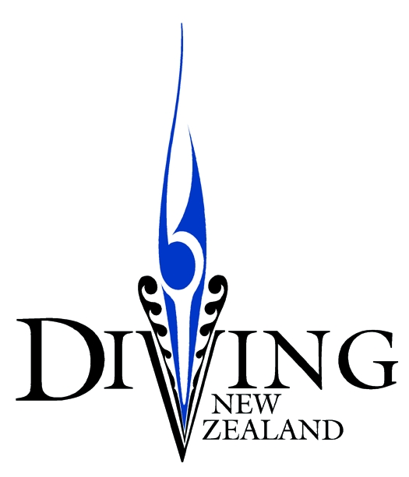

PO Box 12101 Telephone: +64 9 413 9128
Thorndon Facsimile: +64 9 413 9128 WELLINGTON 6144 Mobile: +64 27 4474179

Diving New Zealand Administrator and Co-ordinator 2020

Diving New Zealand (DNZ) is the National Sports Organisation (NSO) responsible for the promotion, fostering and management of springboard and platform diving and competitions at all levels in New Zealand. It is affiliated to the world body, FINA through Aquatics New Zealand, and directly, as the NSO, to Sport New Zealand.

In recent times, diving in New Zealand has been growing through very successful schools’ and club development programmes and now has a much higher profile. Local competitions are attracting record numbers and DNZ now sends senior and junior teams to major international events all around the world. DNZ continues its focus on attracting new participants to the sport at grass roots level and provides career paths to represent New Zealand compete at an elite level on the international stage.

The workload resulting from this success has led to the need for DNZ to contract a paid part-time National Administrator and Co-ordinator as it moves towards a more professional and sustainable organizational. The role is envisaged to average at approximately eight hours per week.

This position would appeal to individuals who have an affinity with sport – an understanding of diving would be helpful but not essential - strong administrative and organizational skills and a desire to be part of a growing organisation providing exciting opportunities for young New Zealanders. You would be keen have a positive influence on supporting pathways for young divers wanting to participate and develop in the sport.

Some of the attributes and skills DNZ is looking for include:

- Strong organisation and office management skills with excellent attention to detail
- Experience in working in an administrative role
- Approachable and proactive attitude to solving issues
- Excellent written and verbal communication skills
- Strong relationship building capabilities, interpersonal and management skills
- Excellent MS Office skills Computer literate – Excel, Word, Power Point, Google
- Budgeting and Bookkeeping skills

The appointee will report to the DNZ Board via the Chair or a designated Board member so an understanding of governance and management would be an advantage. Similarly, familiarity with the not for profit sector and the process of voluntary organisations would be valuable.

Personal traits of our successful appointee will include:
- Ability to work with other people and within a team
- An intuitive, adaptive, innovative and creative mind-set
- Integrity and fairness – open, honest and impartial
- Critical thinking
- Respect and Inclusiveness – treat others with dignity and respect
- Common sense

Time commitment, term and remuneration
The role is open to individuals living throughout New Zealand who have the right to work here.
We anticipate the role starting in April 2020 for an initial term of 50 weeks with a review after three months.

Remuneration will paid be on an invoice basis for itemized time worked at a rate of $25 per hour excluding GST

The position is a contract for services and the appointee will be responsible for paying their own tax.
Closing Date
The closing date for applications is Sunday 22 March 2020 at 8pm.
Applications with an appropriate CV should be forwarded to deputychair@divingnewzealand.org.nz

